9.5

All the steps:

Device['88:4A:EA:69:E3:09']
Out[81]: PressProdVibrationsMonitor(machine=Machine(account=Account(name='KTFLR'), mtype='External Maintenance', name='2500(3)T Line'), mac='88:4A:EA:69:E3:09', label='2500(3)T Trimming Ram ')

d1 = _

d1
Out[83]: PressProdVibrationsMonitor(machine=Machine(account=Account(name='KTFLR'), mtype='External Maintenance', name='2500(3)T Line'), mac='88:4A:EA:69:E3:09', label='2500(3)T Trimming Ram ')

q1 = DeviceData.bigtable.query('accel_energy_512', mac = d1.mac, timestamp = ('2018-9-4 12:00', '2018-9-4 13:00'))

q1
Out[101]: <anaximander.data.gcbigtable.BigTableQuery at 0x7fd0ca9f1b00>

s1 = q1.sequence()

s1
Out[103]: <NxDataSequence[DeviceDataSchema](6884 rows)>

s1.data.head()
Out[104]:
mac \
timestamp
2018-09-04 12:00:00.190000128+00:00 88:4A:EA:69:E3:09
2018-09-04 12:00:00.720000+00:00 88:4A:EA:69:E3:09
2018-09-04 12:00:01.240000+00:00 88:4A:EA:69:E3:09
2018-09-04 12:00:01.760000+00:00 88:4A:EA:69:E3:09
2018-09-04 12:00:02.280000+00:00 88:4A:EA:69:E3:09

Machine m1:

As we can see, d1 means a device, and a device may associate with one machine here, and we have some information for this machine, like account of this machine(this may correspond to our user), the type, the name. Besides, we also have the info for the device. So by doing d1.machine.(some features of this machine), we can find:

the machine correspond to this device:
d1.machine
Out[107]: Machine(account=Account(name='KTFLR'), mtype='External Maintenance', name='2500(3)T Line')

the account of this device:
d1.machine.account
Out[108]: Account(name='KTFLR')

the type of this machine:
d1.machine.mtype
Out[109]: 'External Maintenance'

the name of this machine:
d1.machine.name
Out[110]: '2500(3)T Line'

and the info about this device:

the mac address for this device:
d1.mac
Out[113]: '88:4A:EA:69:E3:09'

the label for this device:
d1.label
Out[114]: '2500(3)T Trimming Ram '

we query from bigtable by giving the field, mac address, and timestamps (from one time to another)
s1 means the sequence of data of this query, by using plot(), we can see the time series directly.

The query
q1 = DeviceData.bigtable.query('accel_energy_512', mac = d1.mac, timestamp = ('2018-9-4 12:00', '2018-9-4 13:00'))

q1
Out[124]: <anaximander.data.gcbigtable.BigTableQuery at 0x7fd0c9c19710>

sequence of data correspond to this query:

s1 = q1.sequence()

s1
Out[118]: <NxDataSequence[DeviceDataSchema](6884 rows)>

s1.plot()
Out[119]: <matplotlib.axes._subplots.AxesSubplot at 0x7fd0c9c365f8>

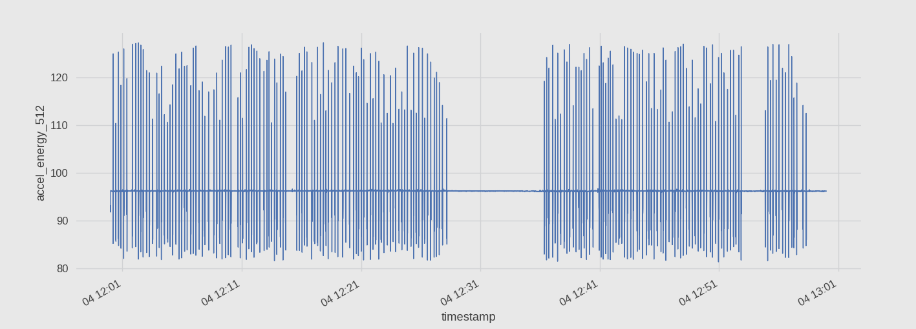
Illustration 1: ts for machine1

Machine M2:

Device['88:4A:EA:69:43:E3']
Out[125]: PressProdVibrationsMonitor(machine=Machine(account=Account(name='KTFLR'), mtype='External Maintenance', name='4002 T P Line'), mac='88:4A:EA:69:43:E3', label='4002Trimming Press')

d2 = _

d2
Out[127]: PressProdVibrationsMonitor(machine=Machine(account=Account(name='KTFLR'), mtype='External Maintenance', name='4002 T P Line'), mac='88:4A:EA:69:43:E3', label='4002Trimming Press')

d2.machine
Out[128]: Machine(account=Account(name='KTFLR'), mtype='External Maintenance', name='4002 T P Line')

d2.machine.account
Out[129]: Account(name='KTFLR')

d2.machine.name
Out[130]: '4002 T P Line'

d2.machine.mtype
Out[131]: 'External Maintenance'

d2.mac
Out[132]: '88:4A:EA:69:43:E3'

d2.label
Out[134]: '4002Trimming Press'

q2 = DeviceData.bigtable.query('accel_energy_512', mac = d2.mac, timestamp = ('2018-9-4 12:00', '2018-9-4 13:00'))

q2
Out[137]: <anaximander.data.gcbigtable.BigTableQuery at 0x7fd0c9bf83c8>

s2 = q2.sequence()

s2.data.head(1)
Out[139]:
mac \
timestamp
2018-09-04 12:00:00.460000+00:00 88:4A:EA:69:43:E3

timestamp \
timestamp
2018-09-04 12:00:00.460000+00:00 2018-09-04 12:00:00.460000+00:00

accel_energy_512
timestamp
2018-09-04 12:00:00.460000+00:00 104.74

s2.data.head(1).timestamp
Out[140]:
timestamp
2018-09-04 12:00:00.460000+00:00 2018-09-04 12:00:00.460000+00:00
Name: timestamp, dtype: datetime64[ns, UTC]

s2.data.head(1).mac
Out[141]:
timestamp
2018-09-04 12:00:00.460000+00:00 88:4A:EA:69:43:E3
Name: mac, dtype: object

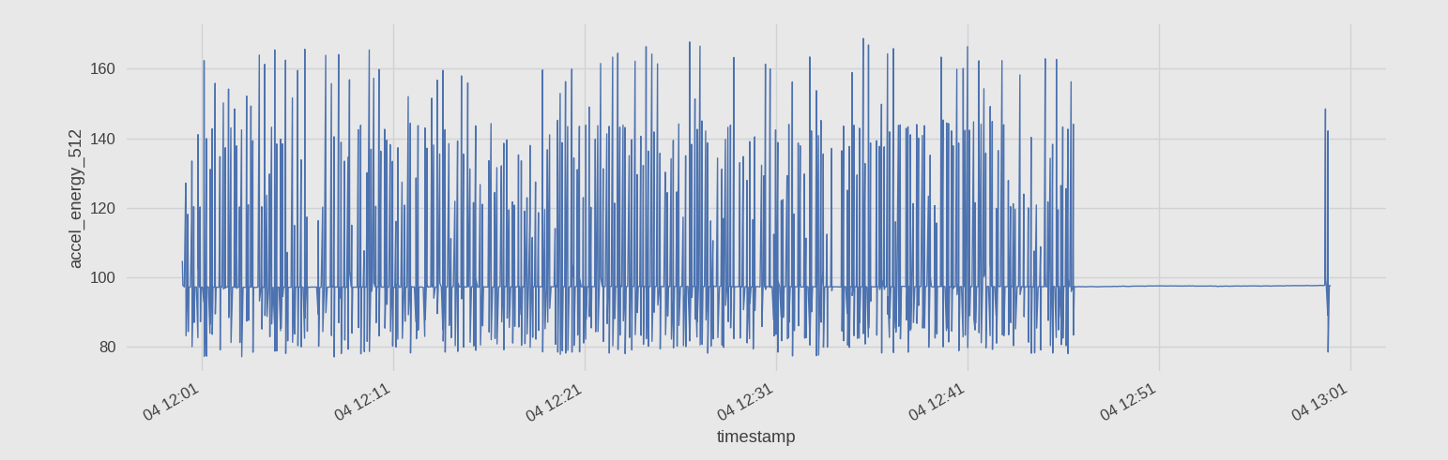
Illustration 2: ts picture for machine2

Machine m3:

Device['88:4A:EA:69:44:BD']
Out[146]: PressProdVibrationsMonitor(machine=Machine(account=Account(name='KTFLR'), mtype='External Maintenance', name='2500(1)TP Line'), mac='88:4A:EA:69:44:BD', label='2500(1)TP Trimming')

d3 = _

d3
Out[148]: PressProdVibrationsMonitor(machine=Machine(account=Account(name='KTFLR'), mtype='External Maintenance', name='2500(1)TP Line'), mac='88:4A:EA:69:44:BD', label='2500(1)TP Trimming')

d3.machine
Out[149]: Machine(account=Account(name='KTFLR'), mtype='External Maintenance', name='2500(1)TP Line')

d3.machine.account
Out[150]: Account(name='KTFLR')

d3.machine.mtype
Out[151]: 'External Maintenance'

d3.machine.name
Out[152]: '2500(1)TP Line'

d3.mac
Out[153]: '88:4A:EA:69:44:BD'

d3.label
Out[154]: '2500(1)TP Trimming'

q3 = DeviceData.bigtable.query('accel_energy_512', mac = d3.mac, timestamp = ('2018-9-4 12:00', '2018-9-4 13:00'))

q3
Out[156]: <anaximander.data.gcbigtable.BigTableQuery at 0x7fd0c9c042e8>

s3 = q3.sequence()

s3
Out[158]: <NxDataSequence[DeviceDataSchema](0 row)>

s3.data.head()
Out[159]:
Empty DataFrame
Columns: [mac, timestamp]
Index: []

It’s a empty dataframe, and we know that m3 is a 'External Maintenance', so it may mean that this external maintenance didn’t work for this perid(from 12:00 to 13:00 2018-9-4).

Machine m4:

Information associated with the machine and device:

Device['88:4A:EA:69:44:E2']
Out[161]: PressProdVibrationsMonitor(machine=Machine(account=Account(name='KTFLR'), mtype='External Maintenance', name='1000 (3)T Line'), mac='88:4A:EA:69:44:E2', label='1000 (3)T Trimming RAM')

d4 = _

d4.machine
Out[163]: Machine(account=Account(name='KTFLR'), mtype='External Maintenance', name='1000 (3)T Line')

d4.machine.account
Out[164]: Account(name='KTFLR')

d4.machine.mtype
Out[165]: 'External Maintenance'

d4.machine.name
Out[166]: '1000 (3)T Line'

d4.label
Out[167]: '1000 (3)T Trimming RAM'

d4.mac
Out[168]: '88:4A:EA:69:44:E2'

q4 = DeviceData.bigtable.query('accel_energy_512', mac = d4.mac, timestamp = ('2018-9-4 12:00', '2018-9-4 13:00'))

q4
Out[172]: <anaximander.data.gcbigtable.BigTableQuery at 0x7fd0c9623390>

s4 = q4.sequence()

s4
Out[174]: <NxDataSequence[DeviceDataSchema](6888 rows)>

s4.data.head(3)
Out[175]:
mac \
timestamp
2018-09-04 12:00:00.200000+00:00 88:4A:EA:69:44:E2
2018-09-04 12:00:00.730000128+00:00 88:4A:EA:69:44:E2
2018-09-04 12:00:01.249999872+00:00 88:4A:EA:69:44:E2

timestamp \
timestamp
2018-09-04 12:00:00.200000+00:00 2018-09-04 12:00:00.200000+00:00
2018-09-04 12:00:00.730000128+00:00 2018-09-04 12:00:00.730000128+00:00
2018-09-04 12:00:01.249999872+00:00 2018-09-04 12:00:01.249999872+00:00

accel_energy_512
timestamp
2018-09-04 12:00:00.200000+00:00 99.66
2018-09-04 12:00:00.730000128+00:00 99.65
2018-09-04 12:00:01.249999872+00:00 99.64

s4.plot()
Out[176]: <matplotlib.axes._subplots.AxesSubplot at 0x7fd0c96c6e48>

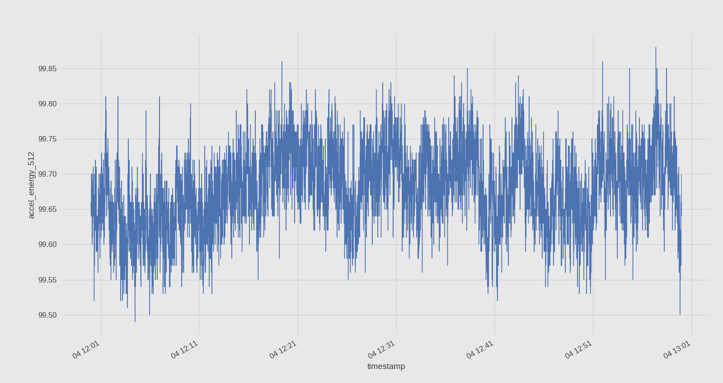
Illustration 3: ts picture for machine m4

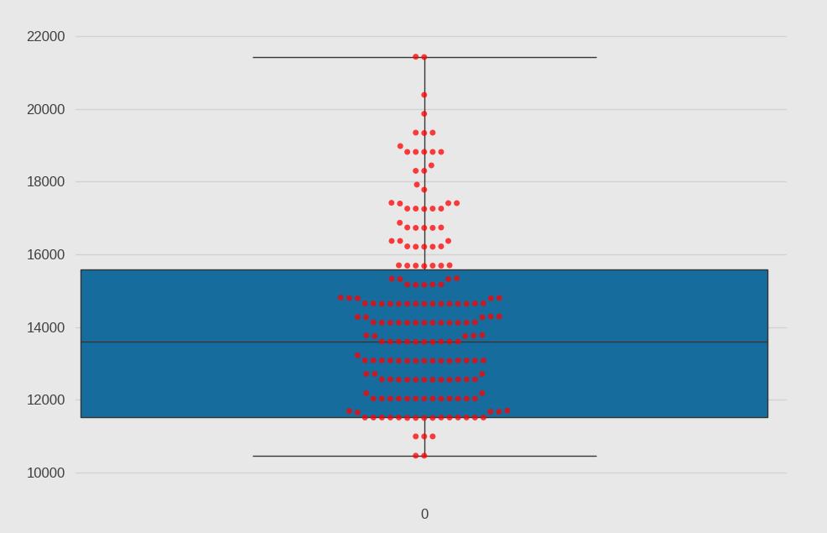
so we can say that
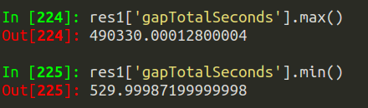

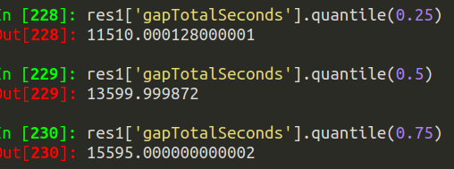

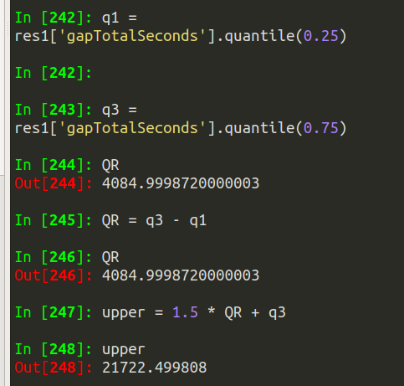

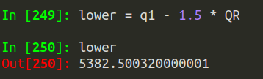

so we can say we have 3 categories:

we will say oulier beyond Upper Fence correspond stoke stop

ouliers smaller than Lower Fence means severals Peaks === one single stroke

the points between the Upper and Lower Fence mean normal interval of stroke. One peak === one stroke
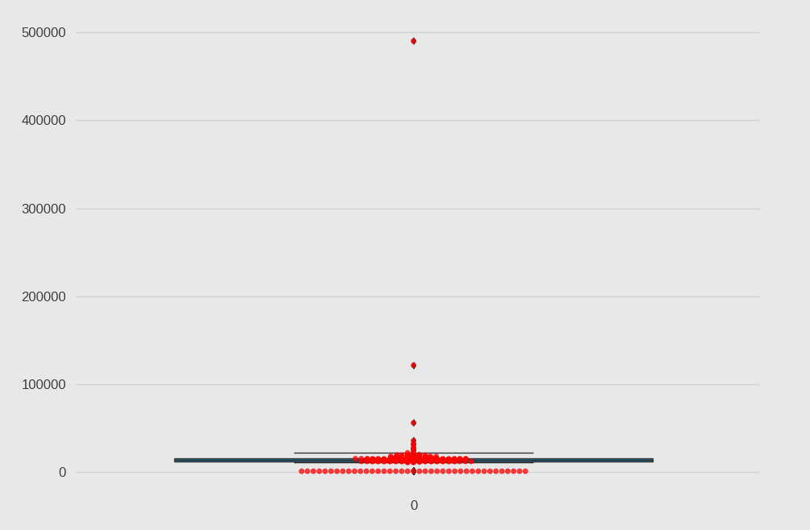

min values, we’d say they’re the DoublePeaks case.
